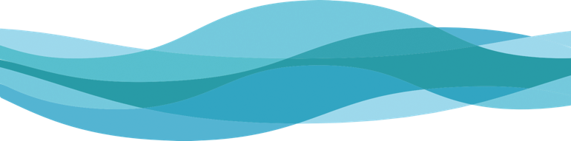

***Promoting your***

***Boating Safety Course!***

By completing a NOWS Self-Assessment and Declaration process, and ensuring your entry-level course complies with the national standards, you are now in a position to market and promote your course as following the NOWS American National Standards. This document provides you with the NOWS Logo and a statement you can use to indicate to the public that your course follows national standards.

By choosing to display the NOWS Logo, you are indicating you have completed a NOWS Self-Assessment of your entry-level course and produced a Supplier’s Declaration of Conformity (SDoC) according to International Standards Organization documents ISO/IEC17050, attesting the course(s) complies with the applicable American National Standards (ANSs).

Simply copy the NOWS logo below and use it on your website, course materials or other published materials relevant to the course. Use a statement like the one below to indicate your course follows the national standards.

Please note that use of the NOWS Logo is reserved solely for course providers mentioned in your SDoC. It should not be made available to any other party.

Macintosh HD:Users:KBrianDorval:TFS Projects:US Sailing:0-On Water Standards USCG:8-Grant V NOWS Marketing 2017:3-NOWS Program Resources:7-NOWS Logos 2018: Following NOWS Logo 2018 FiNAL.pdf

*"This course follows the American National Standards for on-water, skills-based instruction in*

*entry-level recreational boat operation.”*

* * * * * * * * * * * * *

If you would like the NOWS Program to promote your NOWS-compliant course, please email the following information to [info@usnows.org](mailto:info@usnows.org):

1.  Name of your Organization  
2.  Title of the entry-level course that complies with the NOWS  
3.  Two sentence (~25-word) description of the course

4.  Link to the course information/registration page on your website

The information will be posted at: <https://www.watersportsfoundation.com/on-water-boating-skills-courses/>

*Disclaimer:* This NOWS self-assessment and declaration action plan is advisory only and its use entirely voluntary. The National On-Water Standards (NOWS) Program, United States Coast Guard, United States Sailing Association, Think First Serve, METCOR LTD, and their subject matter experts and organizations involved in the development of this approach assume no responsibility whatsoever for the use of, or failure to use, its content or any instructional courses or programs on which it is applied, adaptations made for conformity purposes, or any consequences flowing therefrom. Users of this information are responsible for protecting themselves against liability associated with application of its content. This information is a guide to conducting a conformity assessment and is not intended to preclude attainment of desired results by other means.